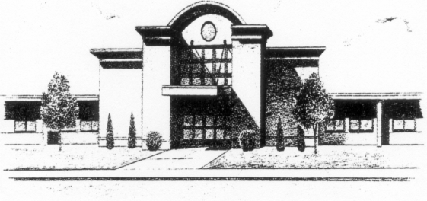
NORDONIA HIGH SCHOOL
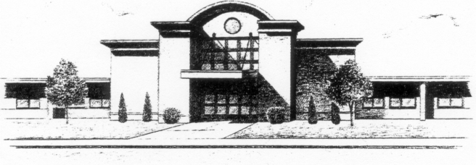
EXAM “OPEN OPTION” PERMISSION FORM

Students at Nordonia High School will be taking second semester exams beginning on Thursday, May 30, 2019 through Tuesday, June 4, 2019. Students are required to be in school during the time in which they have exams scheduled. The exam schedule is closed from 7:15 a.m. through 11:30 a.m. on Friday, Monday and Tuesday. Students are not permitted to leave between exam periods unless they are done for the day. A student may be excused from school at this time if this form is properly filled out, signed by a parent or guardian, and returned to the student's first period teacher by Friday, May 24, 2019.

My child___________________________, in grade______ has my permission to be released from school during the times stated below. I understand that there is no scheduled exam for these times as per the published exam schedule and accept sole responsibility for their transportation and safety.

Thursday, May 30, 2019

ARRIVING TIME_________________

LEAVING TIME__________________

Friday, May 31, 2019

ARRIVING TIME_________________

LEAVING TIME__________________

Monday, June 3, 2019

ARRIVING TIME_________________

LEAVING TIME__________________

Tuesday, June 4, 2019

ARRIVING TIME_________________

LEAVING TIME__________________

PARENT OR GUARDIAN SIGNATURE_____________________________________________________________

